SiftHive Bug Report

Bug# 1
Bug Description
Placeholder text in the email field is too faint to read
Steps to Reproduce:
- Open Extension
- Observe Email Address field
Expected Result
Placeholder text (you@example.com) should be a darker shade of gray so it's easy to read against the light background
Screenshot
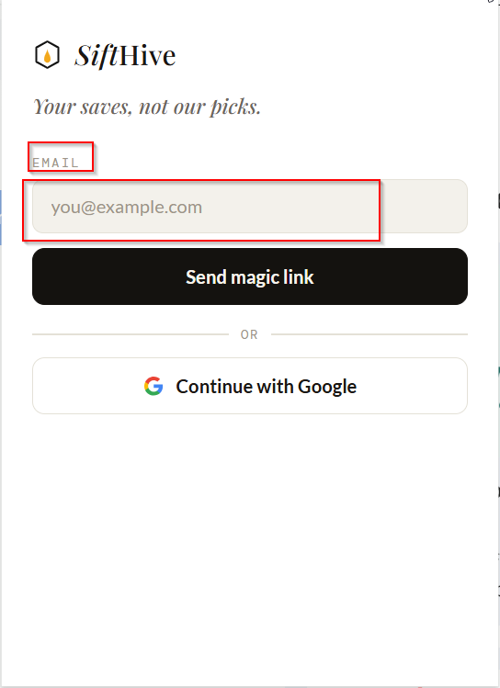

Bug# 2
Bug Description
Too much empty space at the bottom of the extension popup
Steps to Reproduce:
- Open Extension
- Observe at the bottom of the extension popup
Expected Result
Bottom padding of the popup should be reduced so the card height wraps nicely
Screenshot

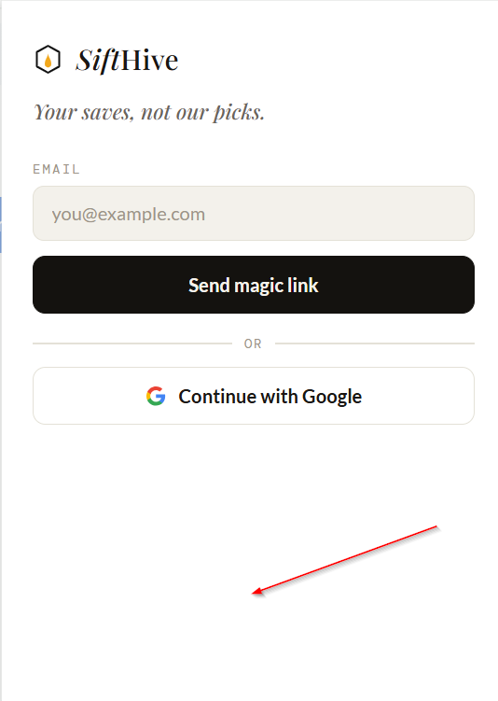

Bug# 3
Bug Description
Tagline and email label are hard to read quickly
Steps to Reproduce:
- Open Extension
- Observe title and Email Label
Expected Result
The tagline "Your saves, not our picks." should use regular text instead of italics, and the EMAIL label should be slightly larger/bolder so users can scan them without straining.
Screenshot
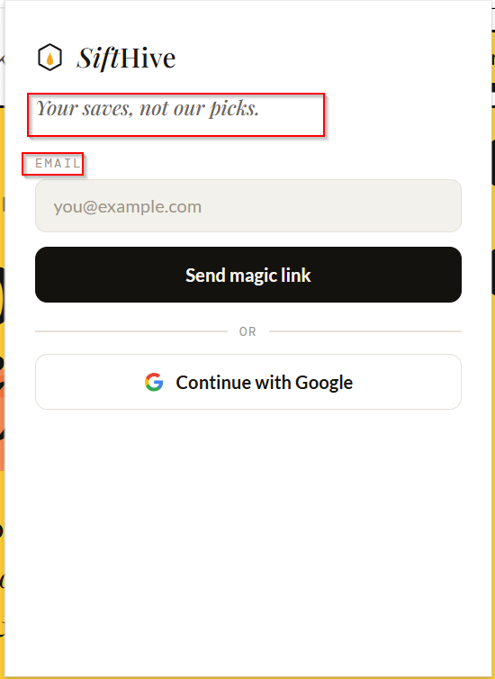

Bug# 4
Bug Description
Sign-in buttons don't match in style and feel
Steps to Reproduce:
- Open Extension
- Observe Send magic link and continue with Google button
Expected Result
Both the "Send magic link" and "Continue with Google" buttons should use matching button heights, border styles, and rounded corners so the layout looks clean and cohesive.
Screenshot
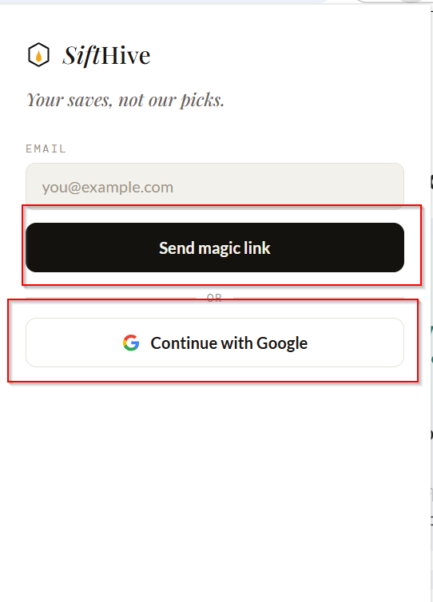

Bug# 5
Bug Description
Email field validation message text needs to be updated
Steps to Reproduce:
- Open the Extension
- Enter test in Email Address field
- Click on send magic link button
Expected Result
When an invalid email format is entered, the validation message should display Please enter a valid email address
Screenshot
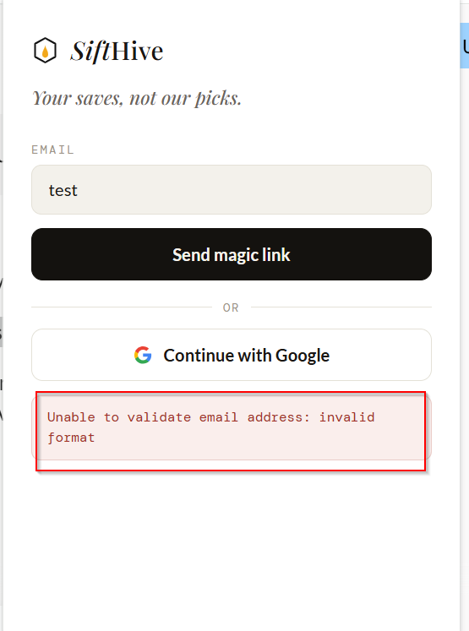

Bug# 6
Bug Description
Low contrast on subtext and email address on "Check your inbox" screen
Expected Result
Message text "We sent a magic link to" and the user's email address (test@gmail.com) should use a darker font color to ensure easy readability against the white background.
Steps to Reproduce:
- Open Extension
- Enter Email Address
- Click on Send magic link button
- Observe check your inbox content
Screenshot
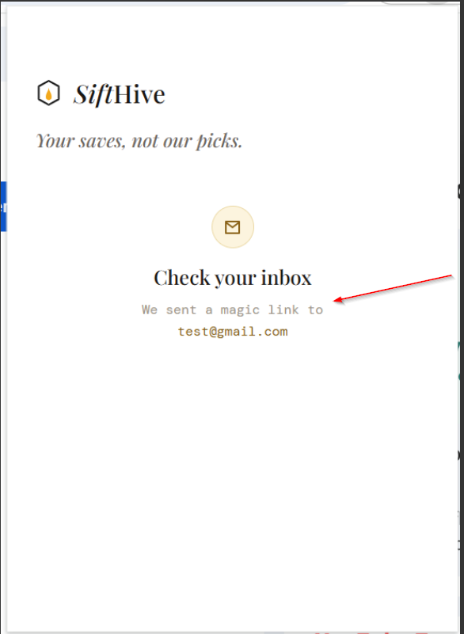
Bug# 7
Bug Description
Profile save success message does not automatically dismiss
Expected Result
When clicking the "Update profile" button in settings, the profile save success message should automatically disappear/dismiss after 3 to 5 seconds instead of remaining permanently on the screen.
Steps to Reproduce:
- Open Extension
- Sign in with Google.
- Click on Setting.
- Click on Update profile button.
Screenshot
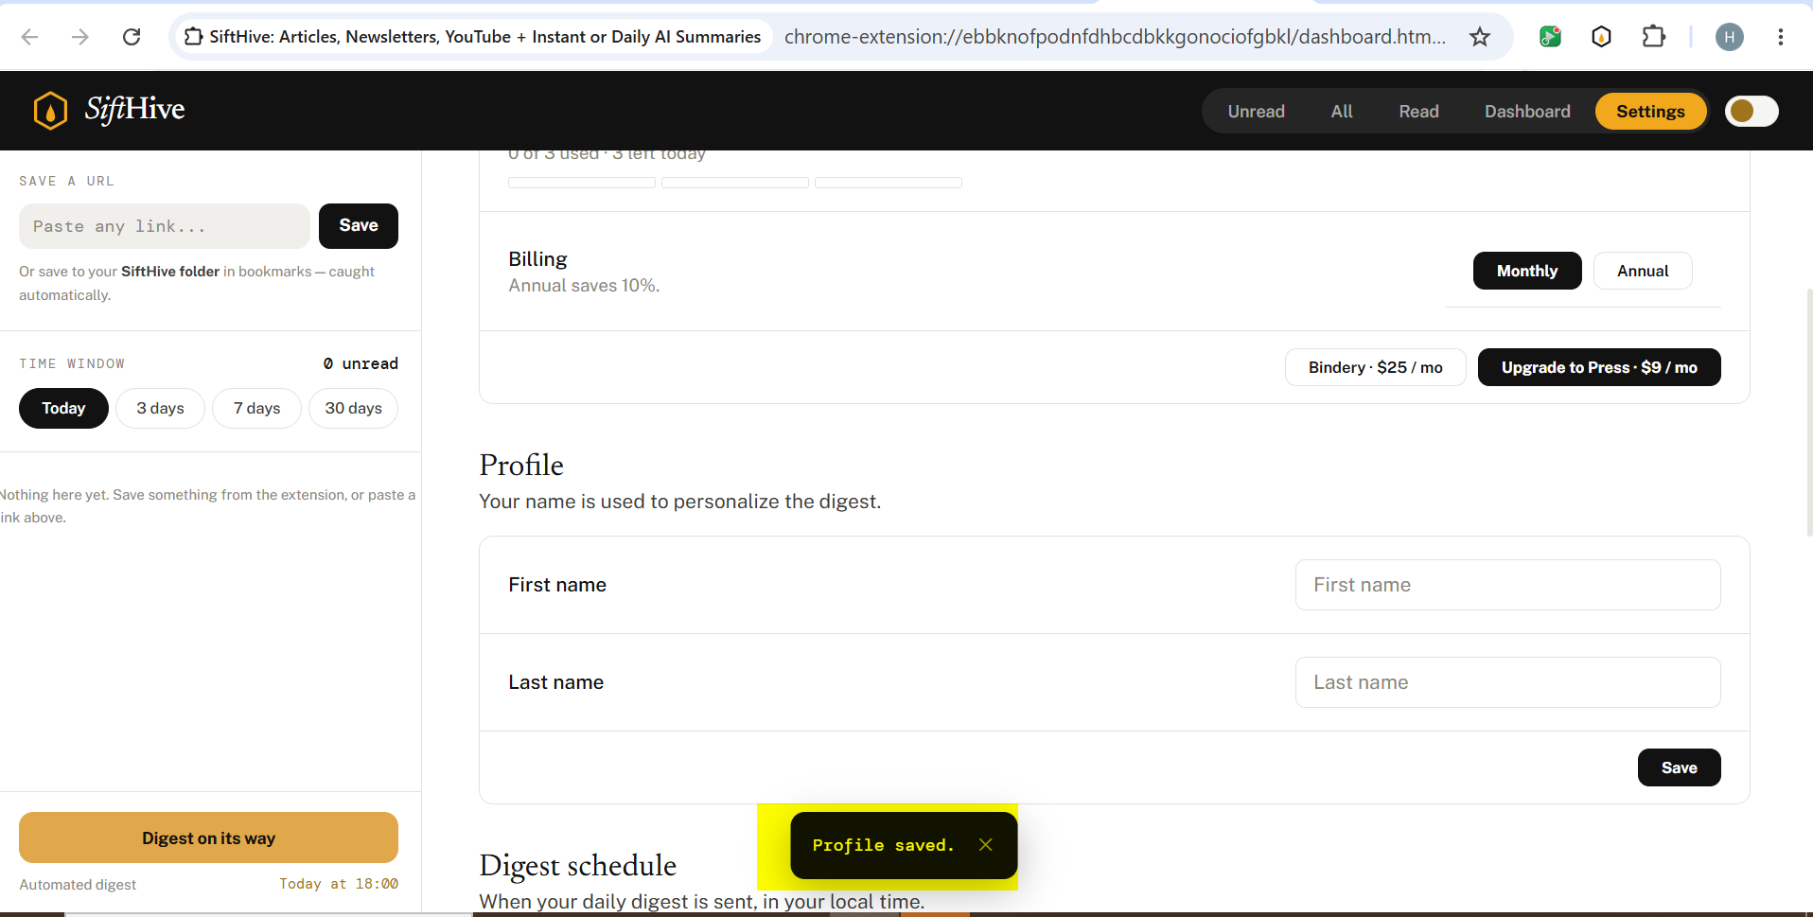

Bug# 8
Bug Description
Duplicate data entries and uncapitalized heading initial in exported Excel file
Steps to Reproduce:
- Open Extension
- Click on the "Export to Excel" button.
- Open the downloaded Excel file.
Expected Result
Exported Excel file should list each saved item only once without duplicates, and column headings should have their first letter capitalized (e.g., "Title", "Domain", "type").
Screenshot
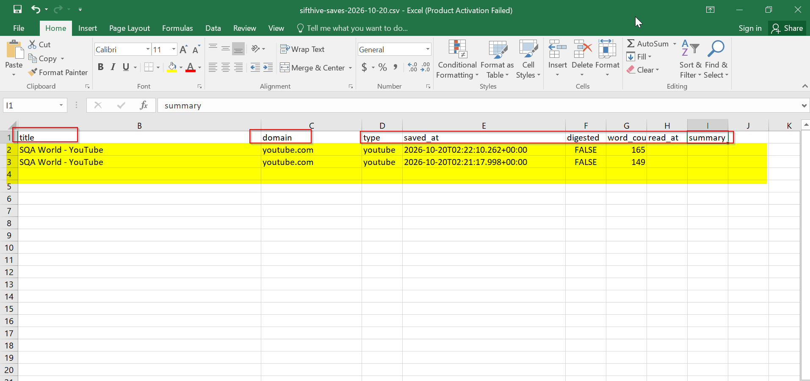

Bug# 9
Bug Description
Schedule success message does not automatically dismiss
Steps to Reproduce:
- Open extension.
- Navigate to digest schedule settings.
- Set a digest schedule and click save.
Expected Result
When saving the digest schedule, the "Digest time saved successfully" message should automatically disappear after 3 to 5 seconds instead of remaining on the screen.
Screenshot
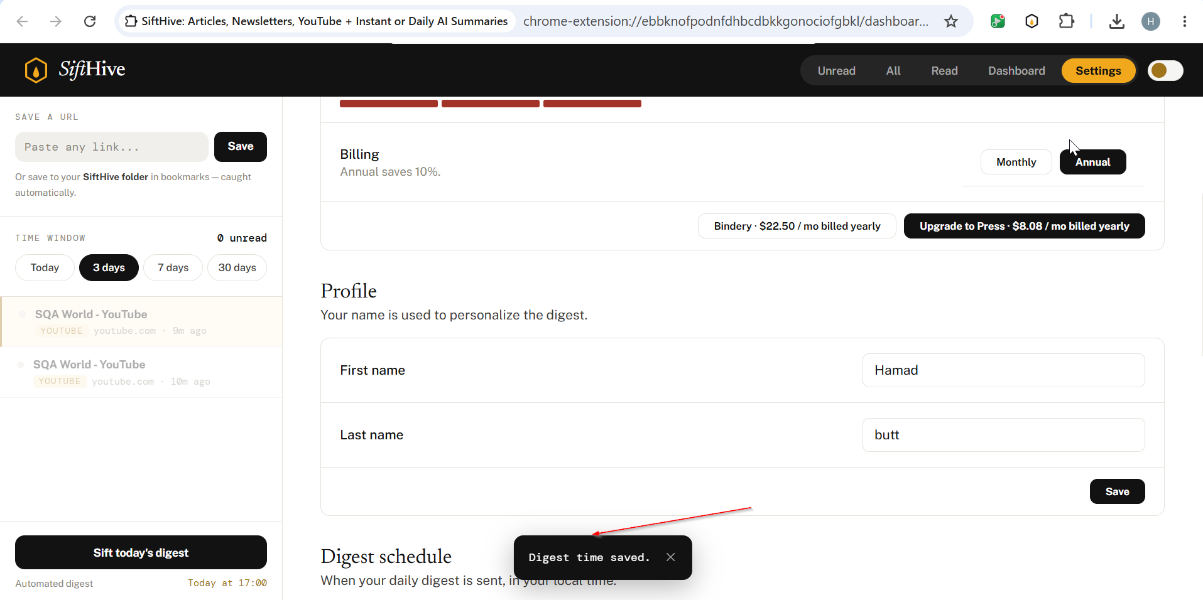

Bug# 10
Bug Description
Missing validation message when clicking search button with empty URL field
Steps to Reproduce:
- Open extension.
- Leave the URL input field empty.
- Click on the search button.
Expected Result
A validation message (e.g., "Please enter a URL") should be displayed indicating that the URL field cannot be empty.
Screenshot
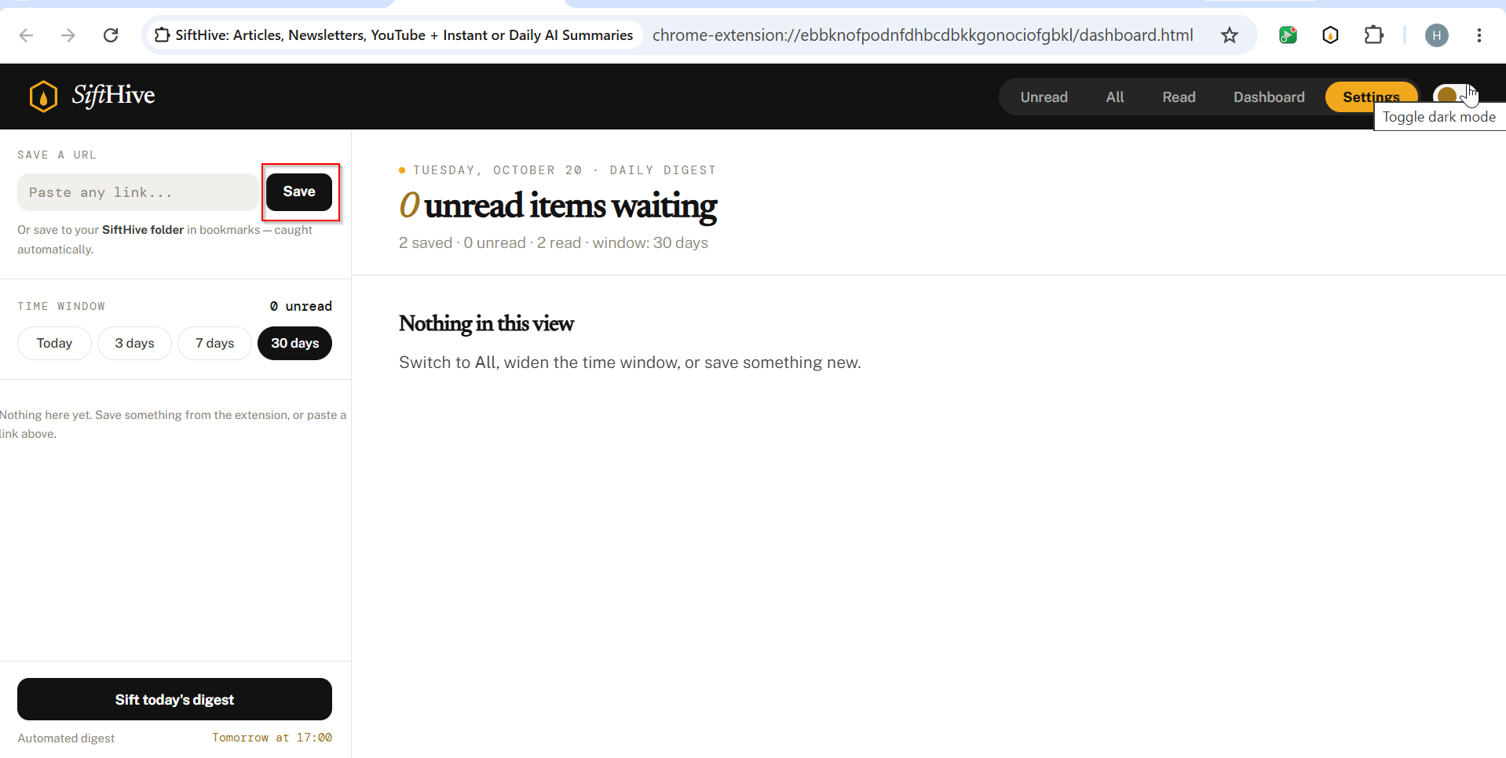

Bug# 11
Bug Description
Save & Sift Today Digest buttons have invisible borders in dark mode
Steps to Reproduce:
- Open extension.
- Enable Dark Mode
Expected Result
Button borders should be clearly visible in dark mode to ensure proper visual distinction.
Screenshot
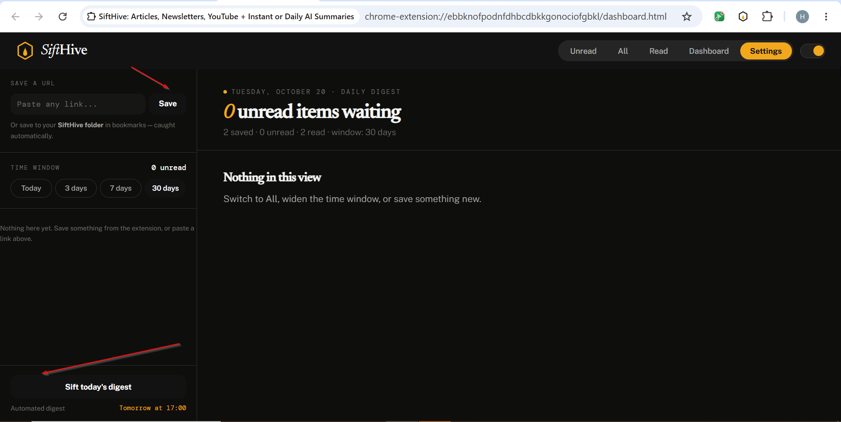
Bug# 12
Bug Description
YouTube text is not visible in dark mode when viewing saved content

Steps to Reproduce:
- Open extension.
- Enable Dark Mode
Expected Result
YouTube text should be clearly visible and readable in dark mode.
Screenshot
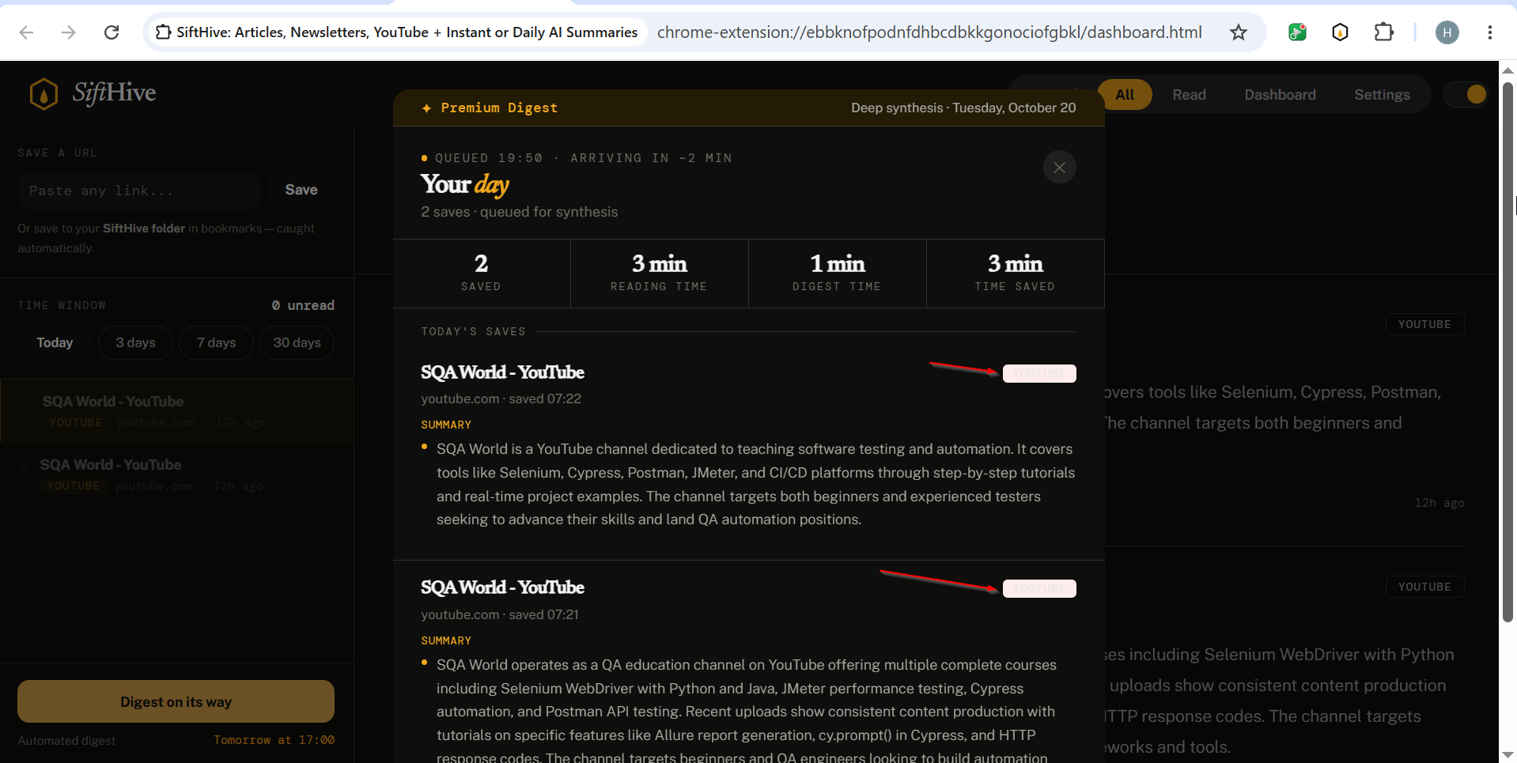

Bug# 13
Bug Description
Save button border is not visible on the Settings screen in dark mode
Steps to Reproduce:
- Open extension.
- Enable Dark Mode
- Navigate to the Settings screen.
- Observe the Save button
Expected Result
Save button border should be clearly visible in dark mode.
Screenshot
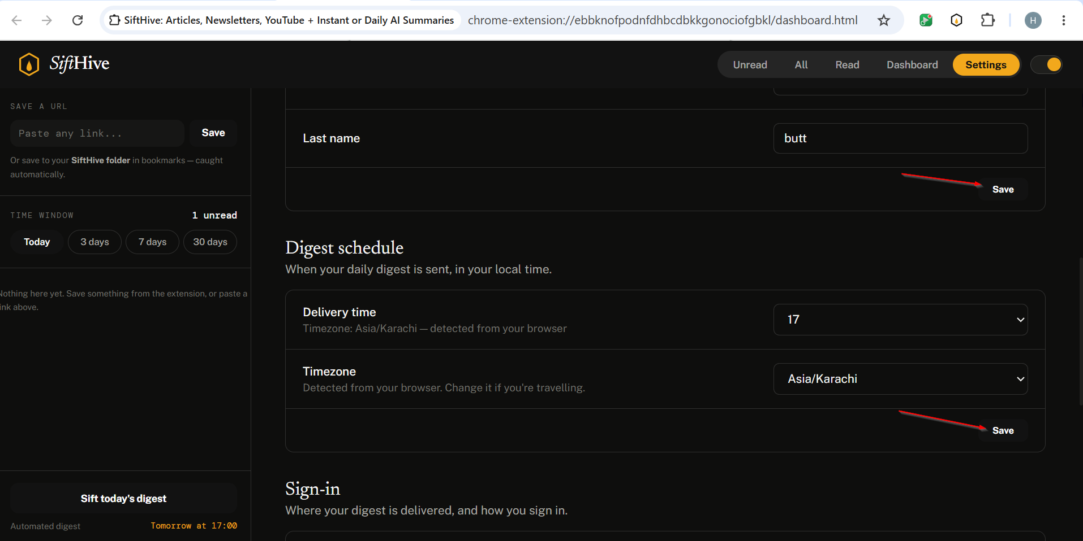

Bug# 14
Bug Description
When a user requests to change their email address, the system sends a confirmation email to their inbox. However, the received email is missing a proper opening greeting (e.g., "Hi [Name]," or "Hello,"). Additionally, the "Confirm change email" text appears twice within the email body
Steps to Reproduce:
- Open extension.
- Go to settings and request an email address change.
- Open the change email notification sent to your inbox.
Expected Result
Notification email should include a proper greeting at the top (e.g., "Hi [Name]," or "Hello,") and display the "Confirm change email" text only once.
Screenshot
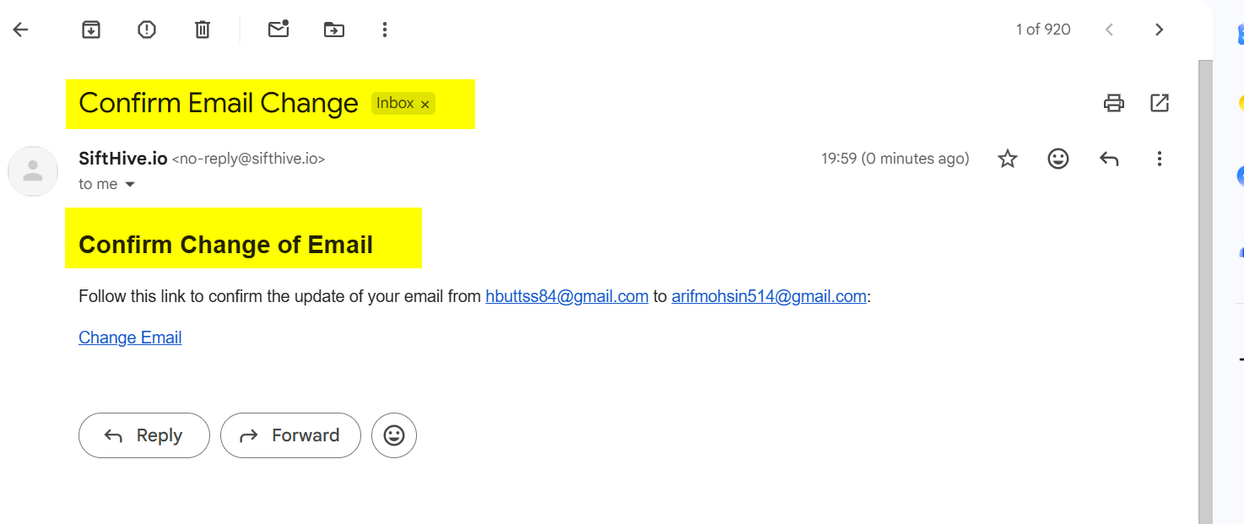
Bug# 15
Bug Description
When editing the profile settings, clicking the "Save" button without entering a first name and last name still triggers the "Profile saved." success message.

Steps to Reproduce:
- Open extension.
- Go to settings and leave the "First Name" and "Last Name" input fields empty.
- Click on the "Save" button.
Expected Result
Profile should not save with empty required fields. A validation error message (e.g., "First name and last name are required")
Screenshot
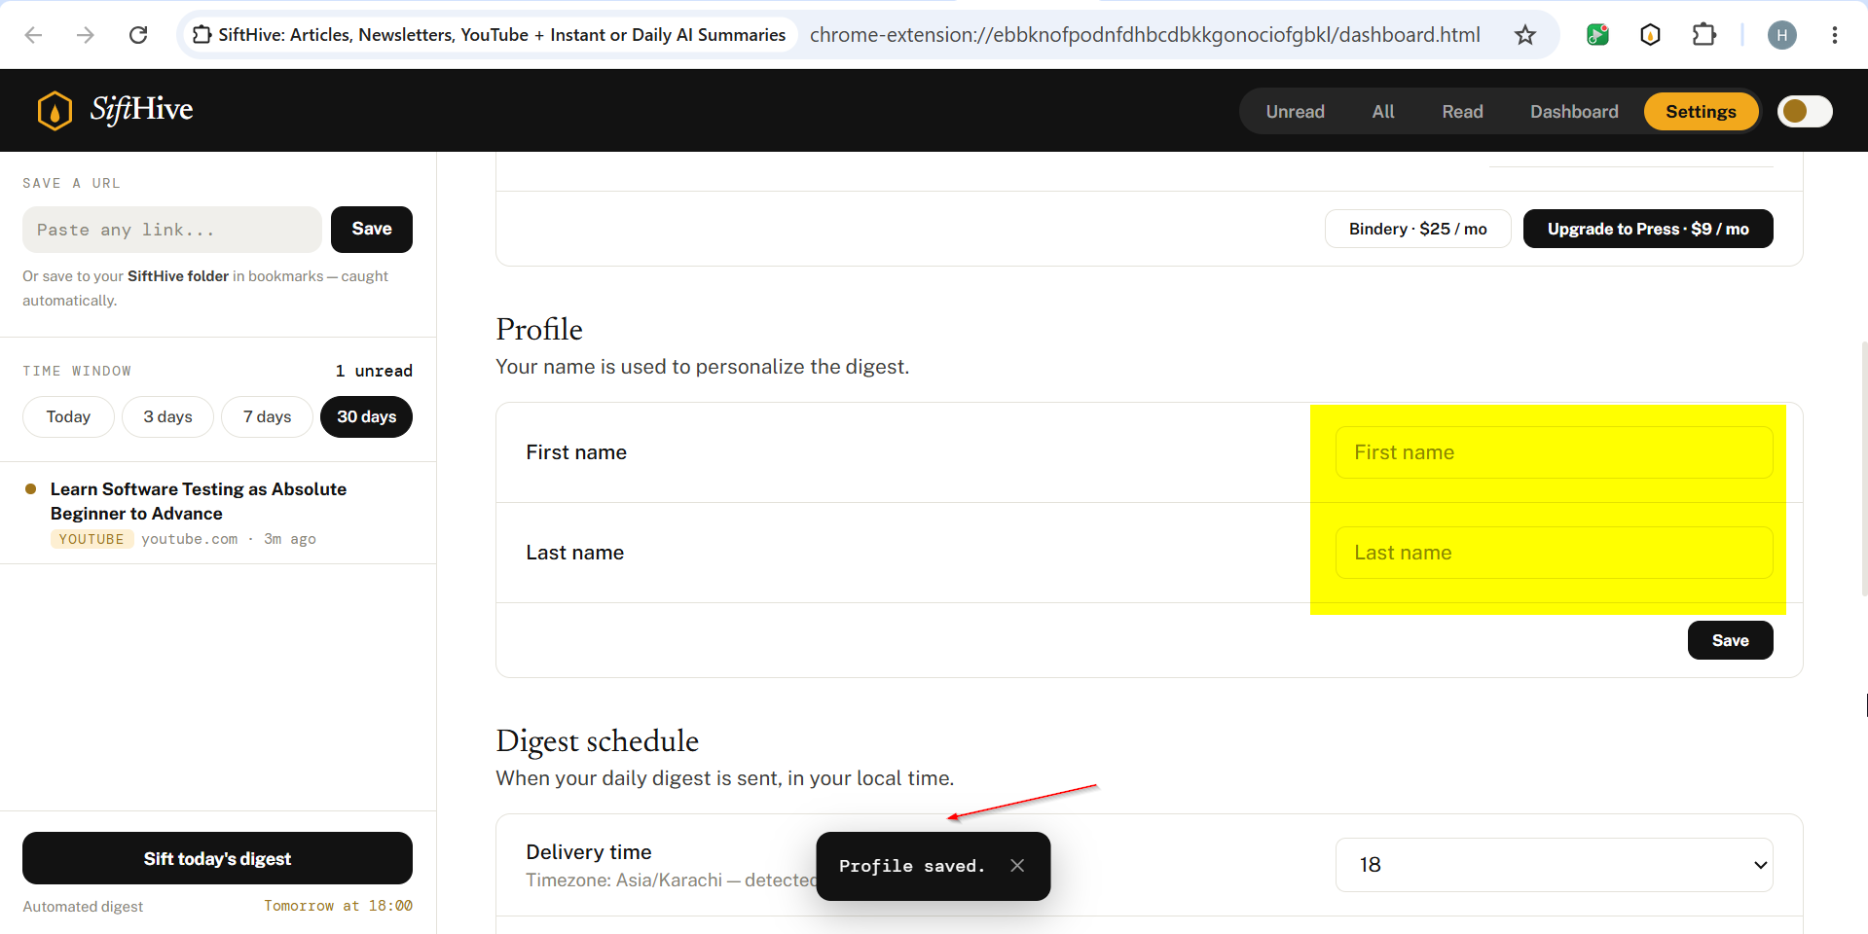
Bug# 15
Bug Description
When a user clicks the "Upgrade" button in the extension settings, the screen changes to white for a few seconds before redirecting to the Stripe payment page. This delay without any loading indicator
Steps to Reproduce:
- Open extension.
- Go to settings
- Click on the "Upgrade" button.

Expected Result
Clicking the "Upgrade" button should show a smooth transition or a clear loading indicator (e.g., "Redirecting to payment..."), rather than displaying an empty white screen before landing on the Stripe payment page.
Screenshot
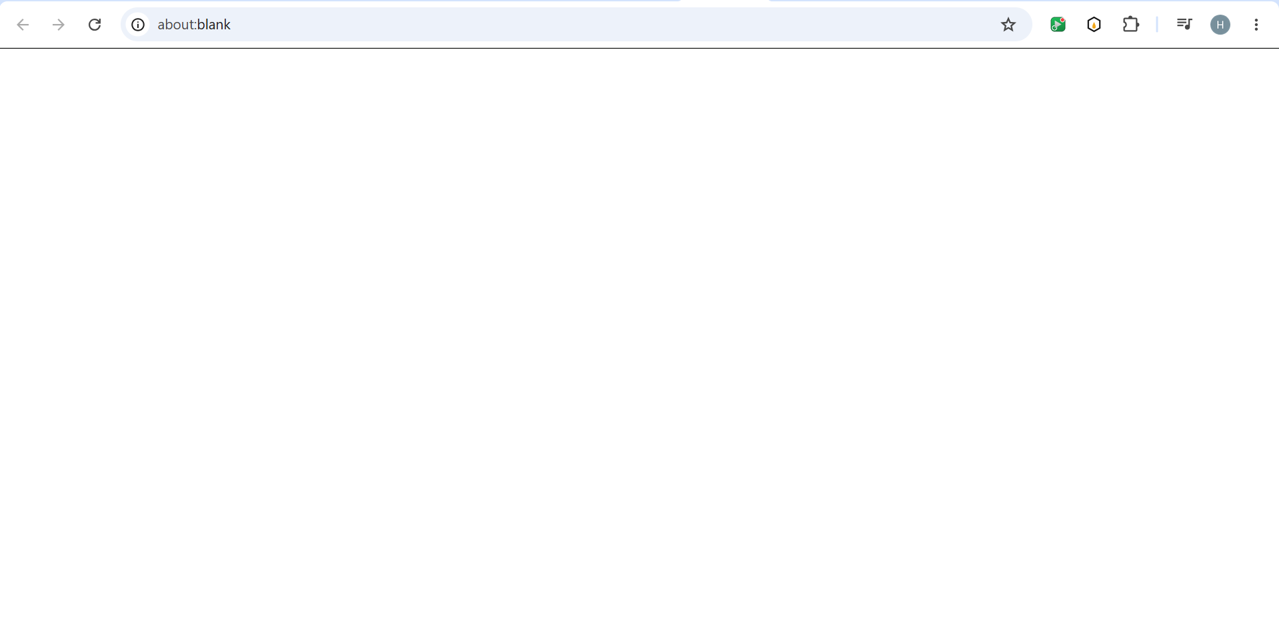
Bug# 16
Bug Description
Confusing order of navigation buttons and filters in top header
Steps to Reproduce:
- Open the extension dashboard.
- Look at the top right navigation bar.
Expected Result
Navigation should follow a logical sequence (Dashboard, All, Unread, Read, Settings)
Screenshot
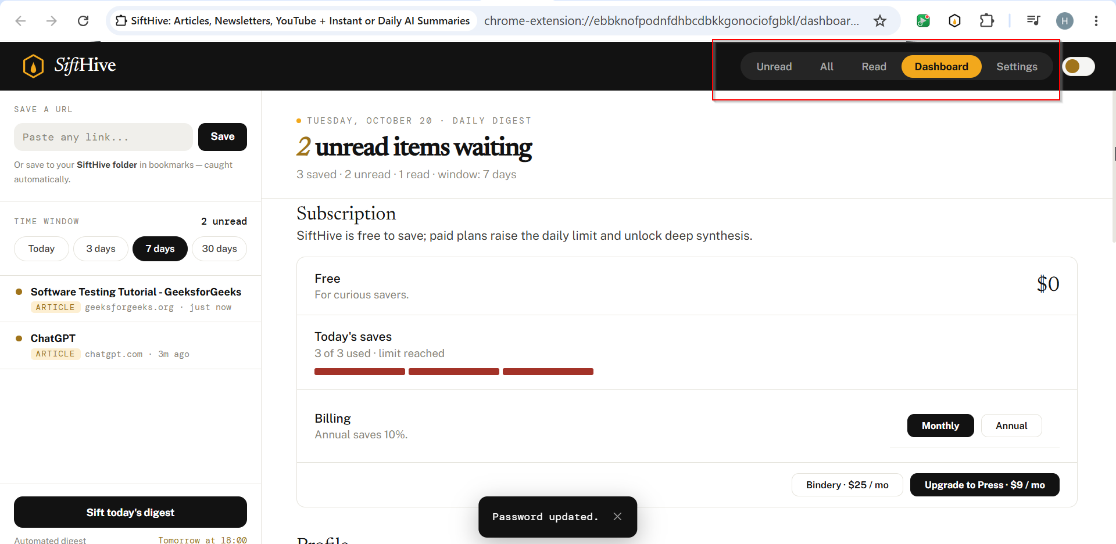
Bug# 17
Bug Description
When a user signs out of the extension, the interface temporarily shows a plain, unformatted "loading" text instead of a proper UI spinner Additionally, clicking the search button after signing out triggers an unhandled exception in the browser console.
Steps to Reproduce:
- Open the extension dashboard.
- Click the sign-out button.
- Click on the search button.
- Open the browser Developer Tools and check the Console tab.
Expected Result
Signing out should show a polished loading indicator, and clicking the search button should gracefully prompt for re-authentication
Screenshot
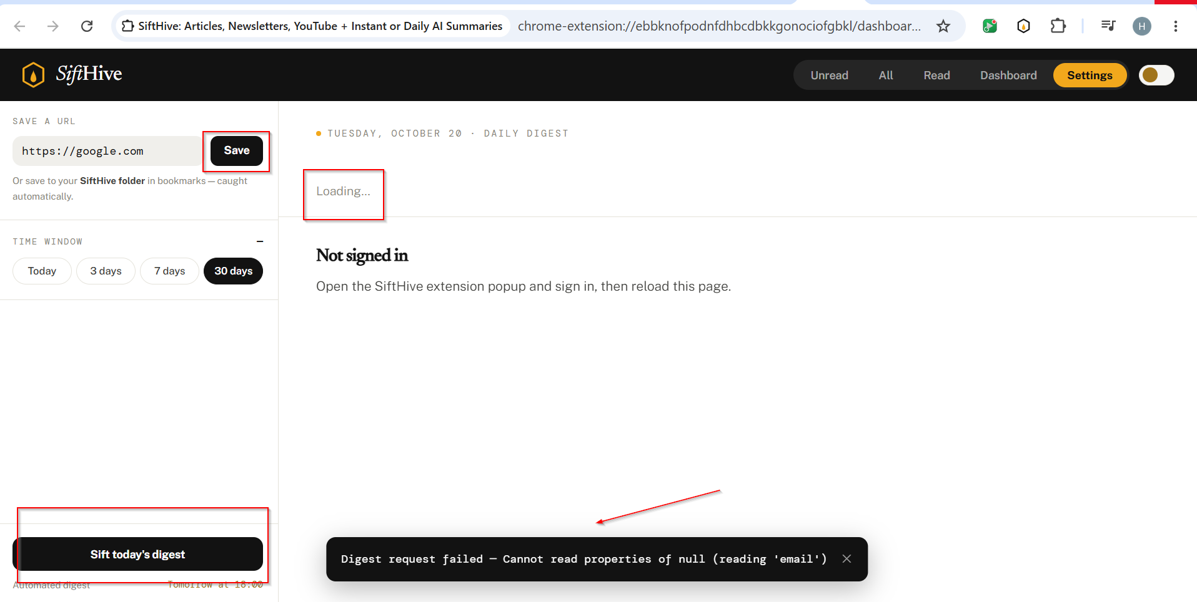

Bug# 18
Bug Description
When a user signs out of the extension and attempts to access or click on the Dashboard, the application throws an unhandled error
Steps to Reproduce:
- Open the extension dashboard.
- Click the sign-out button.
- Click on the Dashboard.
Expected Result
When logged out, clicking on the Dashboard should display an unauthenticated state.
Screenshot
